NAME: K Yamini
REG NO: 192572181

Write a Python program for Tic-Tac-Toe game.
Aim:
To implement a Tic-Tac-Toe game where two players can play and the system checks for winner or draw.
Algorithm:
- Create a 3×3 board using a list.
- Initialize all positions with empty spaces.
- Display the board.
- Take input from Player 1 (X) and Player 2 (O).
- Place symbol in chosen position.
- Check for winner after every move:
  - Rows
  - Columns
  - Diagonals
- If a player wins → display winner.
- If all positions filled → declare draw.
- Repeat until game ends.
Python Code:
# Tic-Tac-Toe Game in Python
# Create board
board = [' ' for i in range(9)]
# Display board
def display():
print("\nBoard:")
print(board[0], "|", board[1], "|", board[2])
print("--+---+--")
print(board[3], "|", board[4], "|", board[5])
print("--+---+--")
print(board[6], "|", board[7], "|", board[8])
print()
# Check winner
def check_winner(player):
win_conditions = [
[0,1,2], [3,4,5], [6,7,8], # rows
[0,3,6], [1,4,7], [2,5,8], # columns
[0,4,8], [2,4,6] # diagonals
]
for condition in win_conditions:
if board[condition[0]] == board[condition[1]] == board[condition[2]] == player:
return True
return False
# Game function
def play():
player = 'X'
for move in range(9):
display()
pos = int(input("Player " + player + ", enter position (1-9): ")) - 1
if board[pos] == ' ':
board[pos] = player
print("# Placing", player, "at position", pos+1)
else:
print("Position already taken! Try again.")
continue
# Check winner
if check_winner(player):
display()
print("Player", player, "wins!")
print("# Winning condition satisfied")
return
# Switch player
player = 'O' if player == 'X' else 'X'
display()
print("Game Draw!")
print("# All positions filled, no winner")
# Start game
play()
Input:
Player X: 1
Player O: 5
Player X: 2
Player O: 8
Player X: 3

Output :
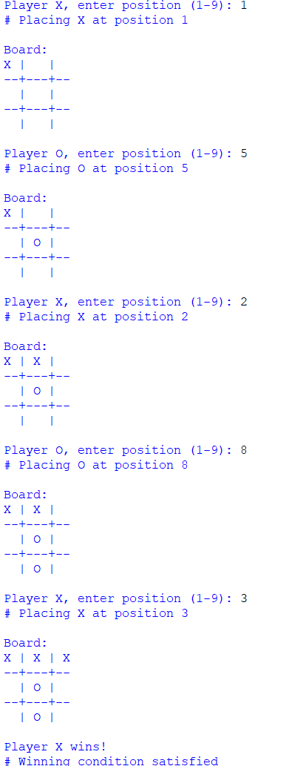
Result:
The Tic-Tac-Toe game is implemented successfully, allowing two players to play and correctly detecting win or draw conditions.

